Zoonoses (sis)
Zoonosis is any disease or infection that is naturally transmissible from vertebrate animals to humans. Animals thus play an essential role in maintaining zoonotic infections in nature. Zoonoses may be bacterial, viral, or parasitic, or may involve unconventional agents. (WHO)

CBC: Zoonotic Diseases (also known as zoonoses) are caused by infections that are shared between animals and people.

Zoonotic parasitic diseases:
Trematodes: Fasciola, Schistosoma mansoni, Heterophyes heterophyes.

Cystodes:

Diphyllobothrium latum

Sparganosis

It is the infection of human tissues by the plerocercoid larva (sparganum) of other pseudophyllidian tapeworms as Diphyllobothrium mansoni (Spirometra erinacei) and D. proliferum.
The definitive host of these cestodes is dogs and cats, while their natural intermediate host is tadpoles and reptiles.
Man can get the infection as follows:
- Swallowing Cyclops containing procercoid with drinking water.
- Eating raw or undercooked flesh of infected 2nd. intermediate host as in Far East.
- Folk medicine in some areas uses the flesh of these animals as fomites or poultice for wounds, eyes or inflamed parts of the body. When the flesh is infected, the sparganum migrates to the hot human tissues.
Pathogenesis and clinical manifestations:
- Presence of sparganum in human tissue elicits an intense inflammatory reaction in the infected area.
- Procercoids after penetrating intestine may pass with circulation to be lodged in the lungs or other organs. Pulmonary infection may cause pulmonary hemorrhage, while brain infection may be fatal.
- Ocular and cutaneous infections usually are due to local application of infected flesh. In the eye there is palpebral edema and conjunctivitis, while in the skin there is inflammation, induration and edema.
- Death of the larva causes intense reaction.

Diagnosis and treatment:
It is established by finding the larva, and usually surgical removal is the only treatment, with additional anti-inflammatory drugs.
Prevention is by filtering or boiling drinking water in endemic areas, thorough cooking of flesh of suspected intermediate hosts and avoiding the use of this flesh as foments.

Taenia saginata
Taenia solium

Echinococcus ganulosus

Hymenolepis nana

Hymenolepis diminuta

Hymenolepis diminuta
(Rat tapeworm)
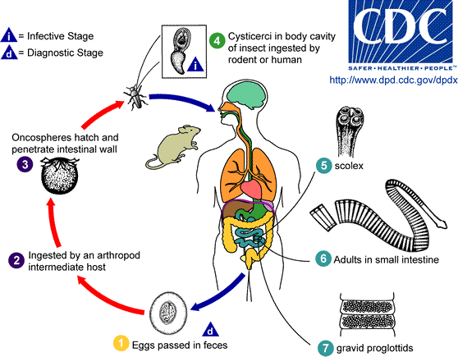

The difference between Hymenolepis nana and Hymenolepis diminuta : complete
 | Hymenolepis nana | Hymenolepis diminuta
Distribution |  | Cosmopolitan
Adult:  Size  Scolex  Mature segment  Gravid segment | Similar, but smaller (0.5x0.15mm) | 30 -60 cm  No hooks  Bigger  Testes and ovary are extended more laterally.  Longer.
Egg:  Size  Shape  Colour  Contents | 30-50μ in diameter  Translucent  Onchosphere | 60-70μ in diameter.  Spheroid, with no polar filaments  Yellowish.  The same.
Definitive host  Intermediate host | Mainly man, rats and mice may be infected.  Optional for man | Mainly rats, man may be infected.  Obligatory for human infection (90 species of arthropods are involved, stored-grain beetles are most suitable)
Larval stage (infective stage) | Cysticercoid | Cysticercoid
Human infection  Pathogenicity | - Ingestion of eggs.  - Ingestion of insects containing Cysticercoid.  GIT, allergic and neurotoxic manifestations, | Ingestion of insects containing Cysticercoid only.  There are mild manifestations. no tissue phase,
Diagnosis:
Recognition of the eggs in faeces.
Treatment:
The same as H. nana.
Prevention and control:
Rodent control and careful examination of clean food free from insects.

Dipylidium caninum
(Dog tapeworm)
Distribution:
Cosmopolitan.
Definitive host:
Dogs and cats mainly, but man specially children can be infected.
Morphology:
Size: 15-70cm in length

- Strobila appears beaded.
- Scolex: has 4 suckers, a retractile rostellum with several rows of rose-thorn shaped hooks.
Mature segment: longer than broad and each contain two sets of genital organs with a genital pore on each lateral margin.
Gravid segment: similar to mature ones in the outer shape (cucumber-seed like) and two lateral pores.
Egg capsule (slide):
- Each contain 8-15 egg
- Egg is spherical, thin shell, 25-40 mic. in size
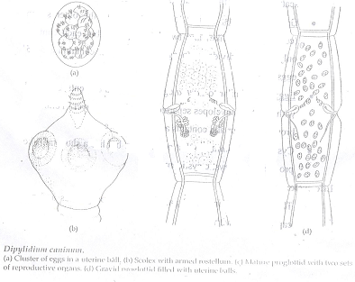
Life cycle:
The adult is a parasite of small intestine. Gravid proglottids and egg capsules pass with faeces.
If the intermediate host, which is the dog flea larva mainly (along with other insects), swallows eggs the onchosphere becomes a cysicercoid larva in the body cavity.
The final host is infected on ingestion of such an insect containing the cysticercoid larva.
Pathogenicity:
Usually symptomless.
Diagnosis:
Accidental finding of gravid segments or egg capsules in the faeces.
Treatment:
Same as Taenia sp.
Prevention and control:
- Routine medical examination and care for pets.
Insecticidal dusting to kill the intermediate host
Nematodes:
Ascaris spp., Hook worms, Trichinella spiralis and filarial worms.

Protozoa:
Trypanosoma spp., Leishmania, Malaria, Cryptosporidium parvum, Toxoplasma gondii and others.

